# CS 340 README Template

## About the Project/Project Title

This project is meant to demonstrate crud mongo db operations using a python object instance to handle those crud operations. In this case we are using a hypothetical animal shelter database that is intended to give a large enough data set to show different use cases such as finding rescue dogs that are trainable. These rescue dogs would then be able to provide emergency services with locating lost hikers or other wilderness rescue operations. The dashboard that accompanies this crud module is to demonstrate that filtering the data and displaying it through visual methods can achieve more easy use of data.

## Motivation

CRUD operations should often be wrapped in a repository pattern, which this python object is meant to fulfill. This allows for separation and decoupling between the running code and the database itself. This is often where validation is verified before adding or modifying the database. This type of repository pattern is commonly used in MVC web apps and RESTful apis. In our case a python application, the dashboard we have created, displays this use of a python module for displaying data visually and to allow user filtering and organization of that data.

## Getting Started

To use this project, you would need to modify the python file to put your own mongo connection info into the appropriate variables as well as ensure that the user has a role for creating and editing as well as reading the database. An understanding of Object-Oriented-Programming is necessary to use this python module. However the dashboard does not require an understanding of the programming language to understand that it’s implementation provides a potentially time saving solution to visualizing data.

## Installation

Python - https://realpython.com/installing-python/

MongoDb - <https://www.mongodb.com/docs/manual/installation/>

MongoDb is a NoSQL database that stores documents in a BSON format and does not require a schema like some other database types. In the read and update functions we use operators such as $set and in the case of the read function the comparison operators. Mongodb is a performant database that will give us the ability to expand and modify how we use the database over time without having to recreate the database every time.

Tools

Jupyter Notebook – is a web app that allows creating and sharing live code and other information, often used for collaboration and data visualization

Text Editor – simplest editor for python that is available in the dev environment

PyMongo - PyMongo is a python library that provides the necessary tools for working with MongoDb in python.

## Usage

This project allows for CRUD operations to be performed on a MongoDb instance. Below is an example of those operations using jupyter notebook. There are also screenshots attached that display the dashboard in 4 different states including the beginning state upon loading. This dashboard demonstrates how a repository pattern module such as our crud module, can be used to solve a business function.

### Code Example

from python_crud_module import AnimalShelter

# Instantiate the AnimalShelter mongo crud module

mongo = AnimalShelter()

# Insert a document into the database

insert_result = mongo.create({"name": "TestName", "breed": "human"})

print(insert_result) # Outputs: True

# Query for document added prievously

read_result = mongo.read({"name": "TestName"})

print(read_result) # Should output

*# Update existing document*

*update_result = mongo.update({"name": "TestName"}, {"breed": "martian"})*

*print(update_result) # Outputs: True*

*# Delete existing document*

*delete_result = mongo.delete({"name": "TestName"})*

*print(delete_result) # Outputs: True*

### Tests

The above example is actually an example of a test but without assertions. We would need to set conditions that verified that the tests were true, though currently any operations other than true would in fact throw an exception.

### Screenshots

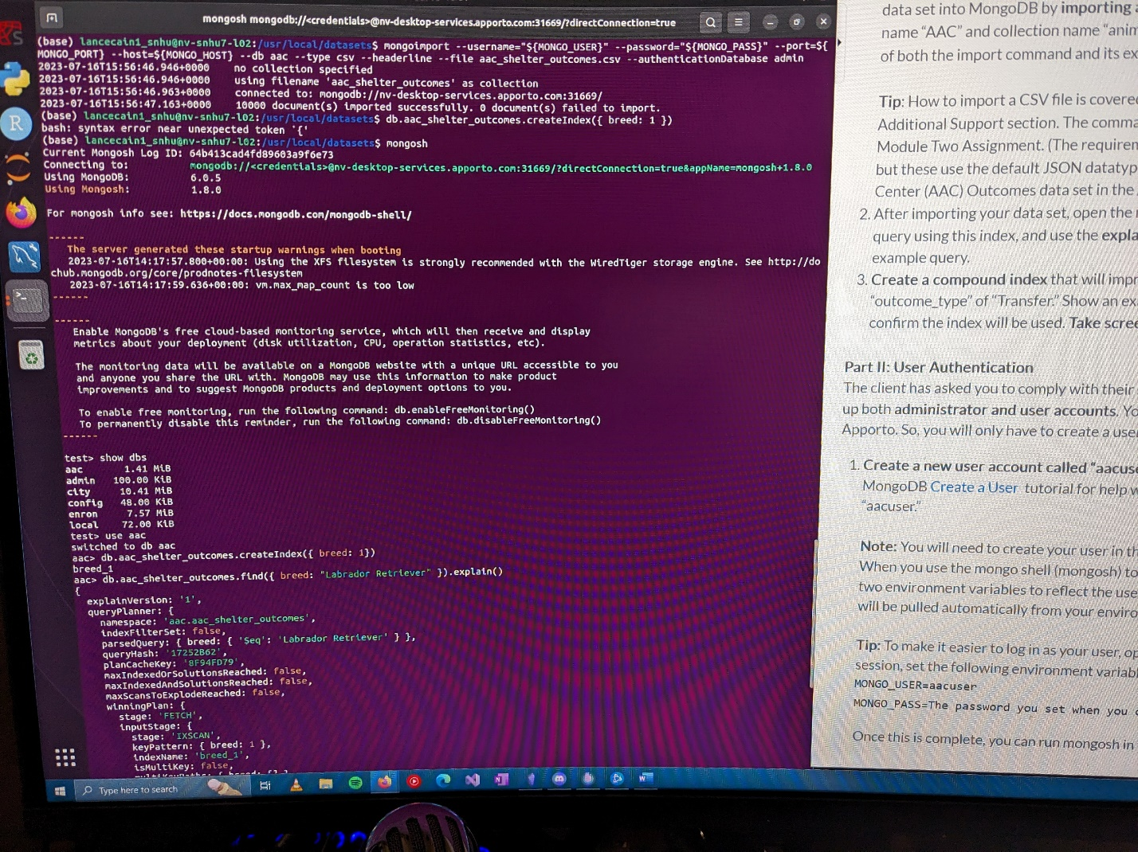

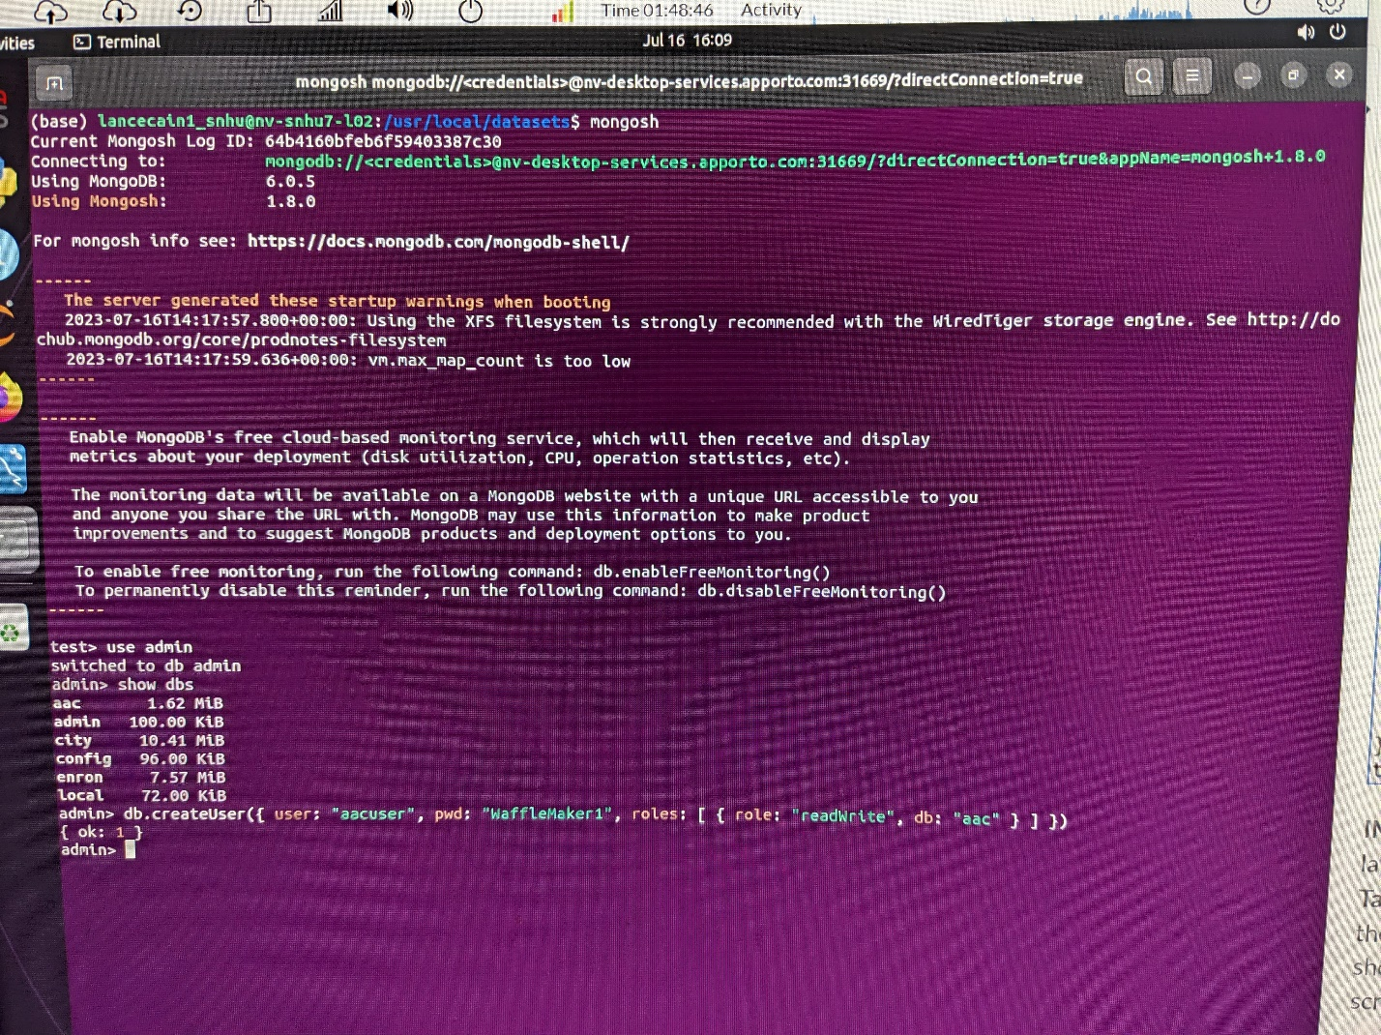

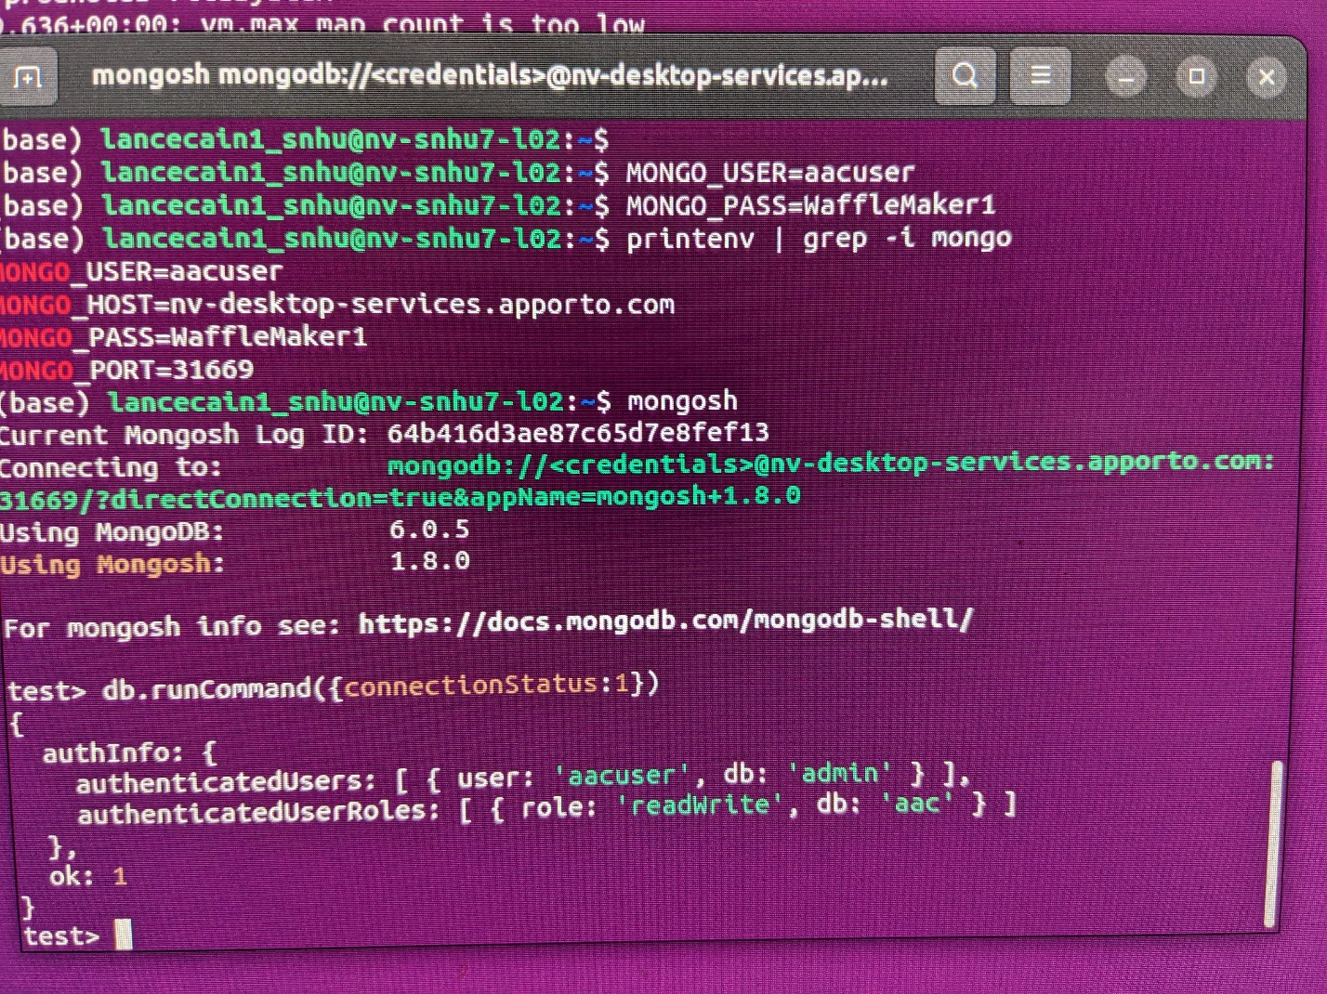

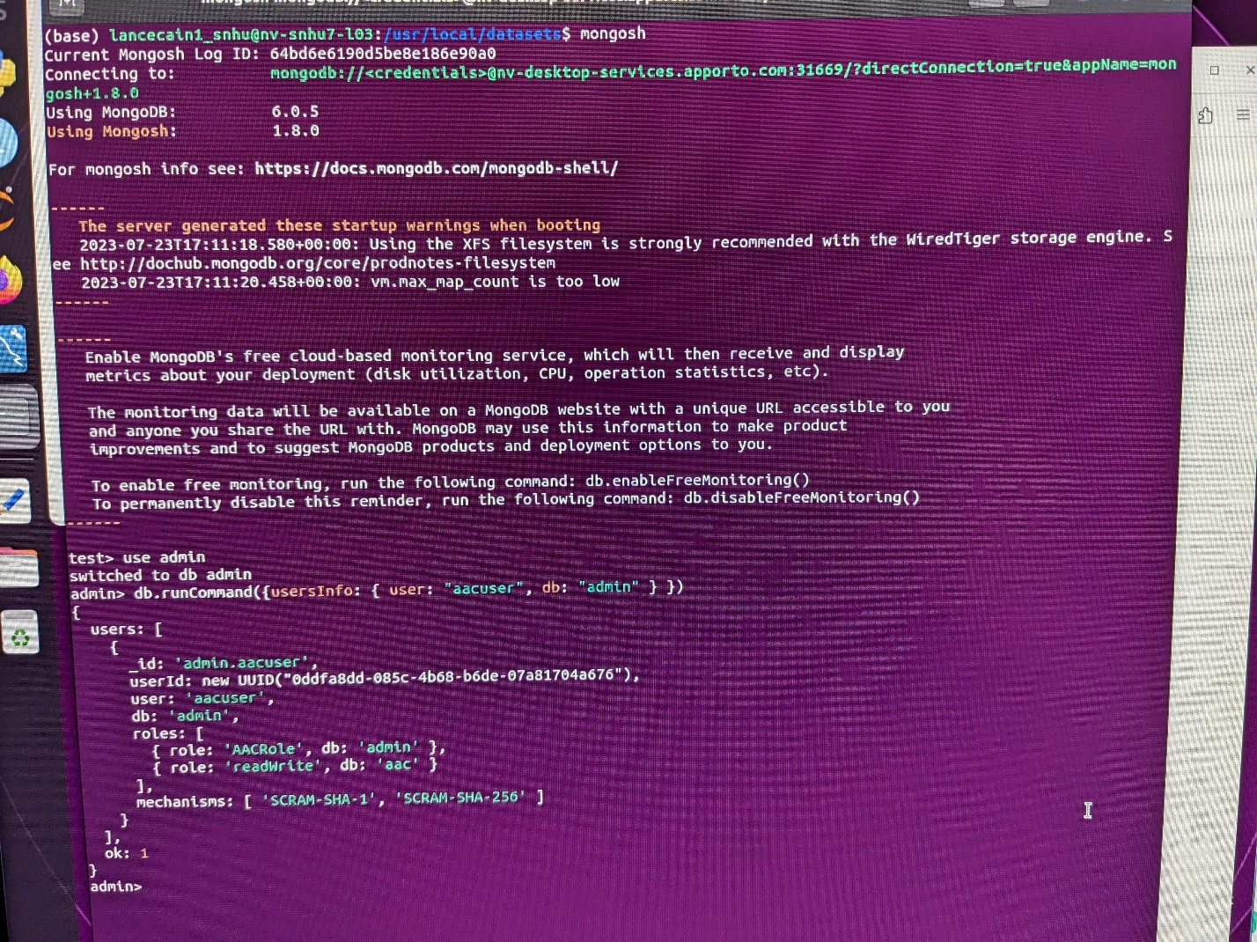

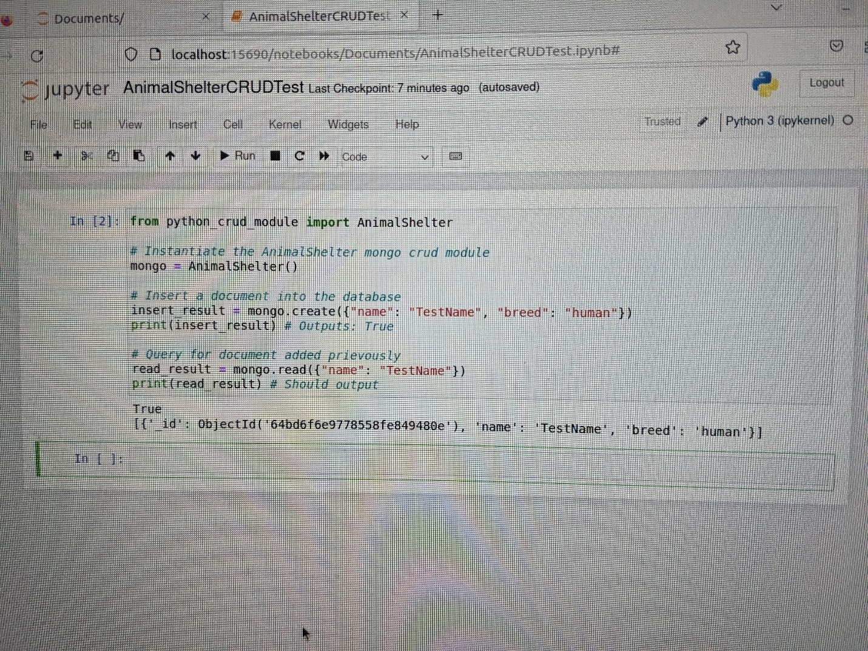

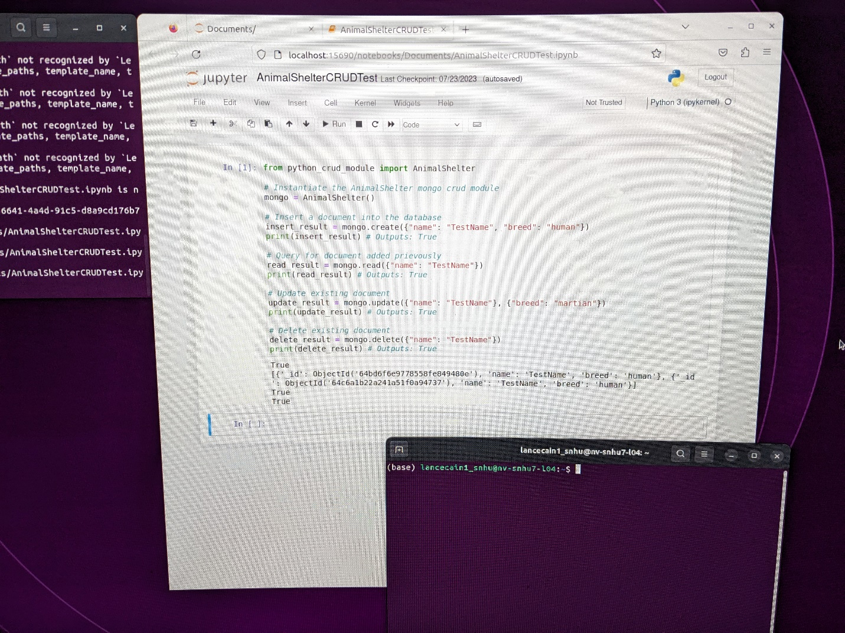

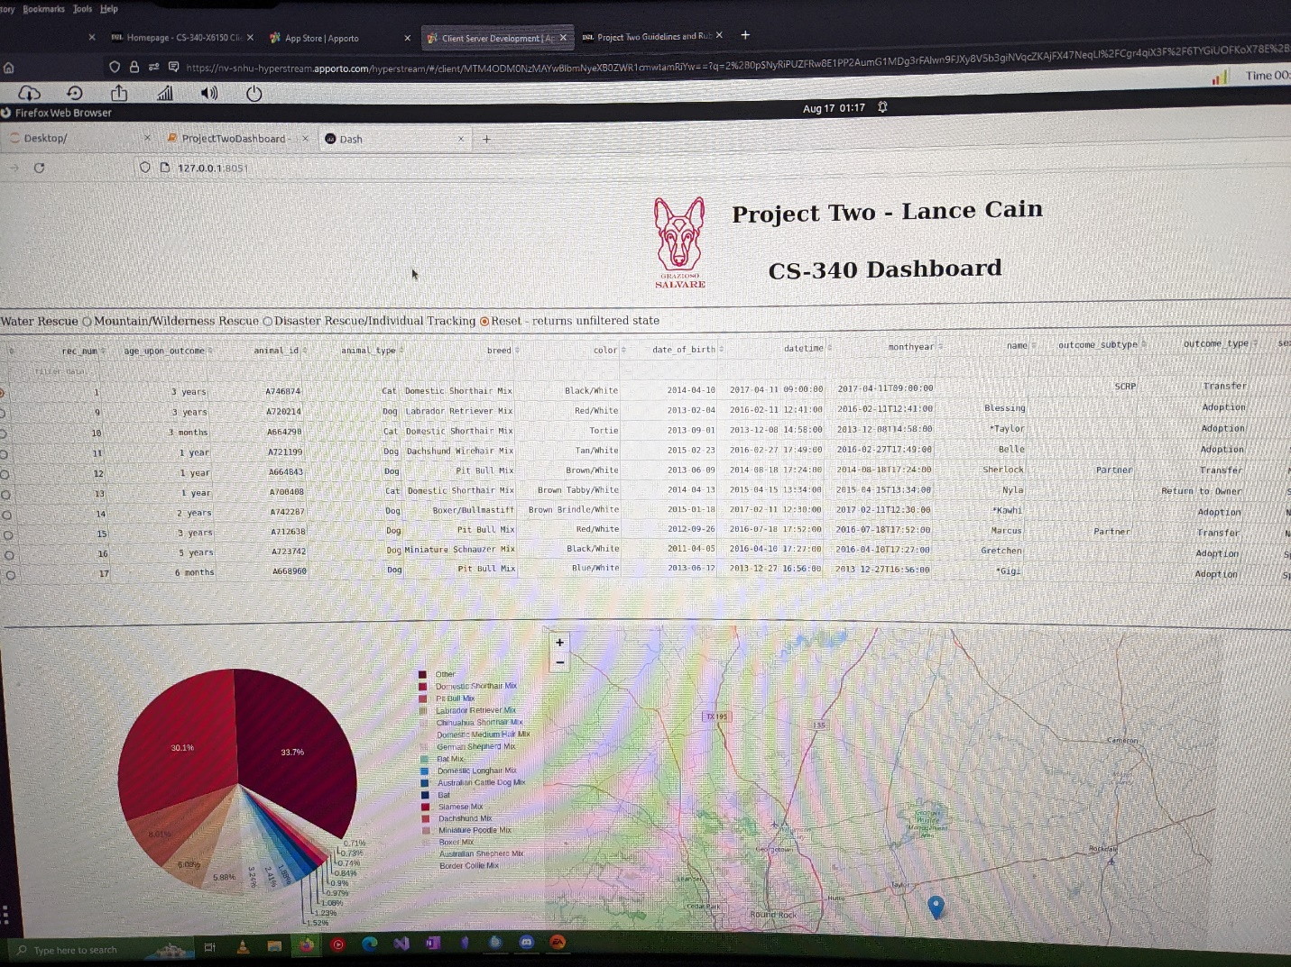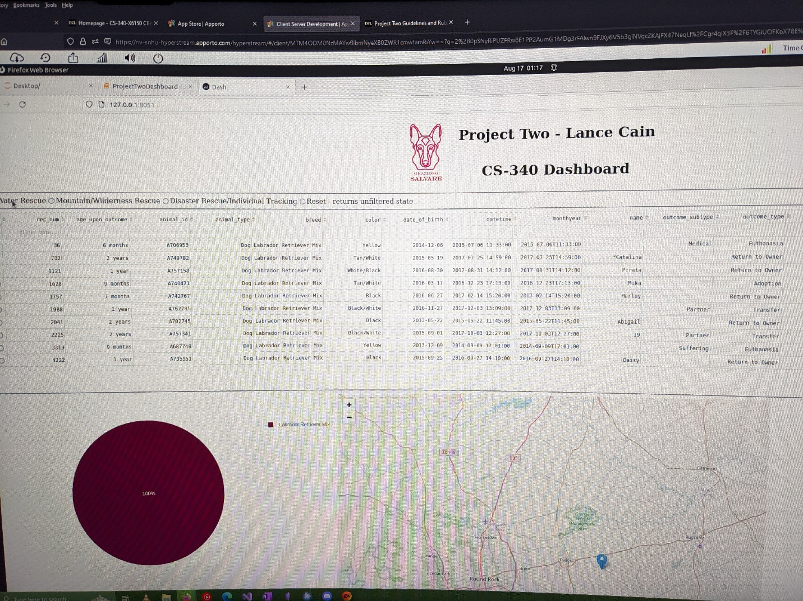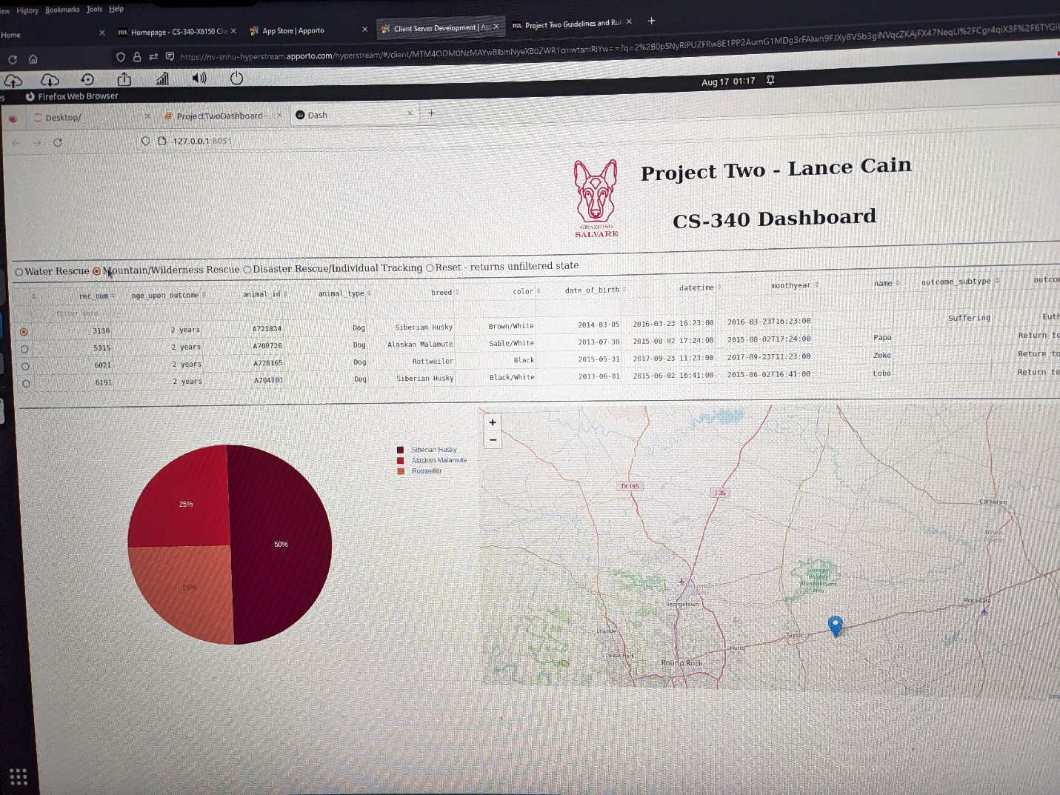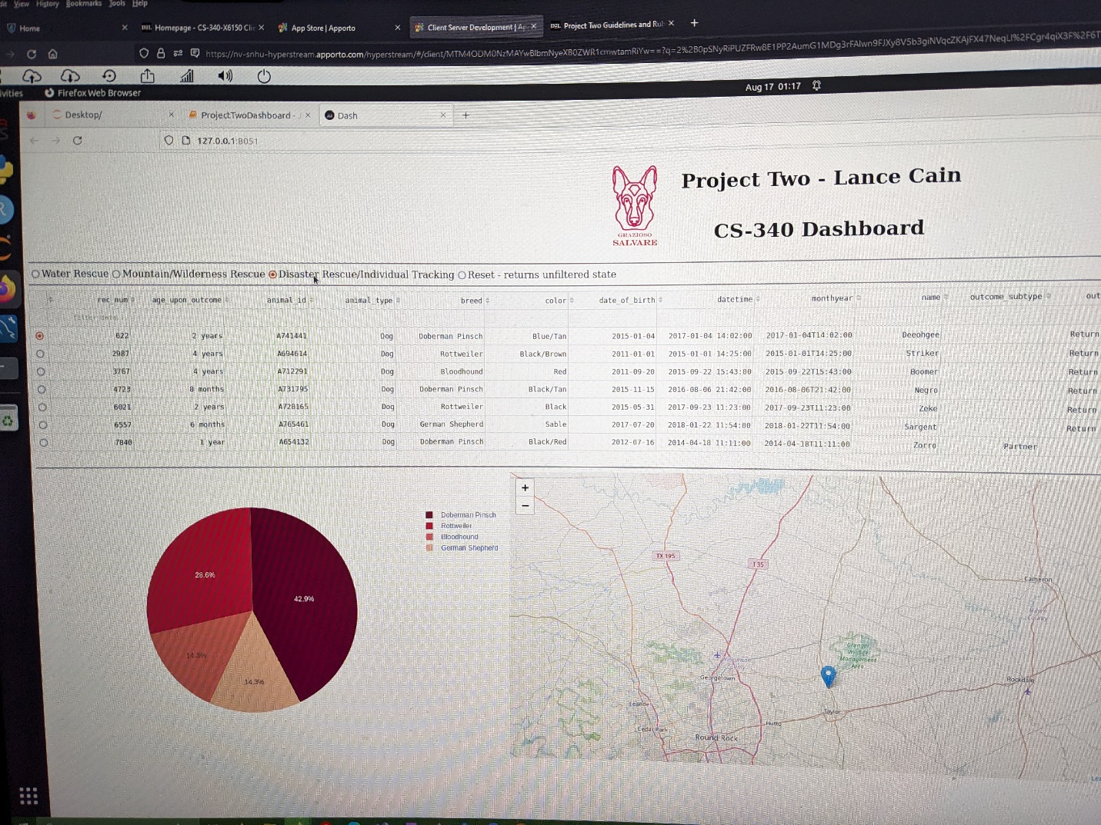

## Contact

Your name: Lance Cain